Software Requirements Specification (SRS)

Movie Ticket Booking Application

Prepared by: Team M.BOOK(VERSION 1.0)
MEMBERS: HUMAGAI SUSHANT
SAINJU NEHA
ADHIKAR SANCITA
AWALE MUKESH

DATE:2026\4\4
Table of Contents
- Introduction
1.1 Purpose
1.2 Document Conventions
1.3 Intended Audience
1.4 Product Scope
1.5 References
- Overall Description
2.1 Product Perspective
2.2 Product Functions
2.3 User Classes and Characteristics
2.4 Operating Environment
2.5 Design and Implementation Constraints
2.6 User Documentation
2.7 Assumptions and Dependencies
- External Interface Requirements
3.1 User Interfaces
3.2 Hardware Interfaces
3.3 Software Interfaces
3.4 Communication Interfaces
3.5 UI Design and color scheme

- System Features
4.1 User Registration & Login
4.2 Movie Browsing
4.3 Ticket Booking
4.4 Payment System
4.5 Admin Panel
- Other Nonfunctional Requirements
5.1 Performance Requirements
5.2 Safety Requirements
5.3 Security Requirements
5.4 Software Quality Attributes
5.5 Business Rules
- Other Requirements
Appendix A: Glossary Appendix
B: Analysis Models Appendix
C: Evolution

Revision History

Name | Date | Reason | Version
M.BOOK | 2026 | Initial Draft | 1.0

1. Introduction
1.1 Purpose
This document provides a detailed description of the Movie Ticket Booking Application. It defines the functional and non-functional requirements for the system, intended for developers, testers, and stakeholders.

1.2 Document Conventions
- REQ = Requirement
- UI = User Interface
- All requirements are uniquely numbered

1.3 Intended Audience
- Developers
- Project Managers
- Testers
- End Users

1.4 Product Scope
The system allows users to browse movies, select showtimes, book tickets, and make payments online. It aims to simplify the movie ticket booking process.

1.5 References
- IEEE SRS Template
- Software Engineering Notes

2. Overall Description
2.1 Product Perspective
This is a standalone mobile and web application connected to a backend server and database.

2.2 Product Functions
- User registration/login
- Browse movies
- View showtimes
- Book tickets
- Online payment
- Booking history

2.3 User Classes
- Customer (Primary user)
- Admin (Manages movies and bookings)

2.4 Operating Environment
- Android / iOS / Web
- Backend server (Node.js / Firebase)
- Database (MySQL / MongoDB)

2.5 Constraints
- Internet connection required
- Payment gateway dependency

2.6 User Documentation
- User guide
- Help section

2.7 Assumptions
- Users have smartphones
- Payment system works properly

3. External Interface Requirements
3.1 User Interfaces
- Login screen
- Movie list screen
- Seat selection screen
- Payment screen

3.2 Hardware Interfaces
- Mobile devices
- Servers

3.3 Software Interfaces
- Payment gateway API
- Database system
3.4 Communication Interfaces
- Internet (HTTP/HTTPS)

3.5 UI Design and Color Scheme
Description:
The Movie Ticket Booking Application uses a modern and visually appealing color scheme designed to enhance user experience, readability, and aesthetic appeal.
Color Palette
Background: Dark Blue (#121826)
Secondary Background: Deep Navy (#1D2733)
Primary Color: Silver Blue (#4674FA)
Accent Color: Gold (#F7C873)
Text Primary: White (#FFFFFF)
Text Secondary: Light Gray (#B0B3B8)
Seat Selection Colors
Available: Blue (#4A90E2)
Selected: Gold (#F7C873)
Booked: Red (#E74C3C)
Design Guidelines
- Dark theme for cinematic experience
- High contrast for readability
- Gold color for important actions
- Consistent UI across all screens
- Minimal and modern design
Typography
Font: Sans-serif (Roboto, Poppins)
Headings: Bold
Body: Regular
Buttons: Medium/Bold

4. System Features
4.1 User Registration & Login
Description
Allows users to create accounts and log in.
Requirements
- REQ-1: User can register using email and password
- REQ-2: User can log in securely

4.2 Movie Browsing
Description
Users can view available movies.
Requirements
- REQ-3: Display list of movies
- REQ-4: Show movie details

4.3 Ticket Booking
Description
Users can select seats and book tickets.
Requirements
- REQ-5: Select movie and showtime
- REQ-6: Choose seats
- REQ-7: Confirm booking

4.4 Payment System
Description
Users can pay online.
Requirements
- REQ-8: Secure payment gateway
- REQ-9: Payment confirmation

4.5 Admin Panel
Description
Admin manages movies and bookings.
Requirements
- REQ-10: Add/update/delete movies
- REQ-11: View bookings

5. Nonfunctional Requirements
5.1 Performance
- System should respond within 2 seconds

5.2 Safety
- Prevent data loss

5.3 Security
- User authentication
- Data encryption

5.4 Quality Attributes
- Reliable
- User-friendly
- Scalable

5.5 Business Rules
- Tickets once booked cannot be cancelled after showtime

6. Other Requirements
- Database backup

Appendix A: Glossary
- UI: User Interface
- API: Application Programming Interface

Appendix B: Analysis Models
Use Case Diagram
MAIN:
- User
- Admin
- Payment gateway

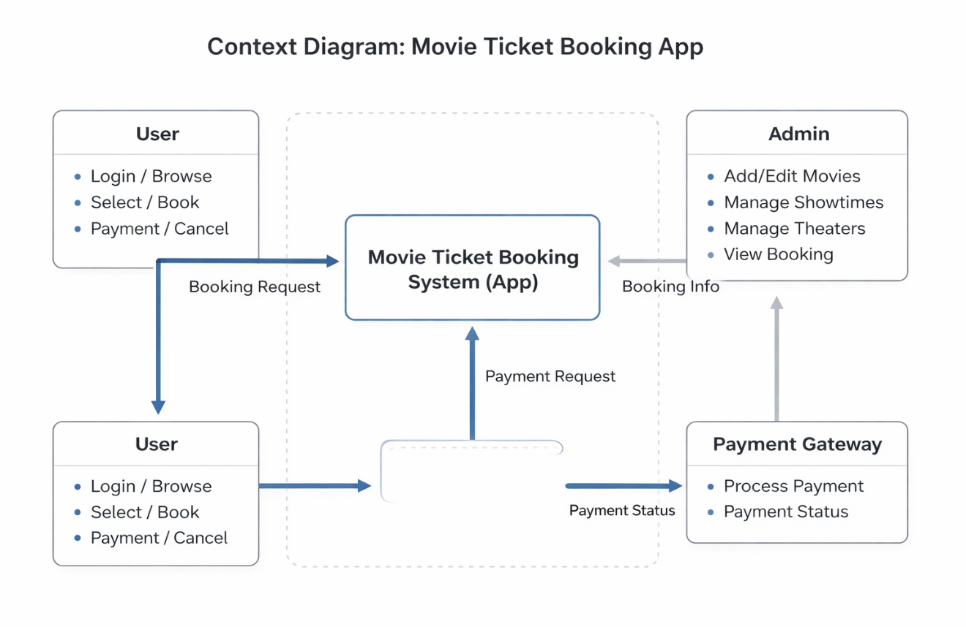
FIG: CONTEXT DIAGRAM

USE CASE DIAGRAM

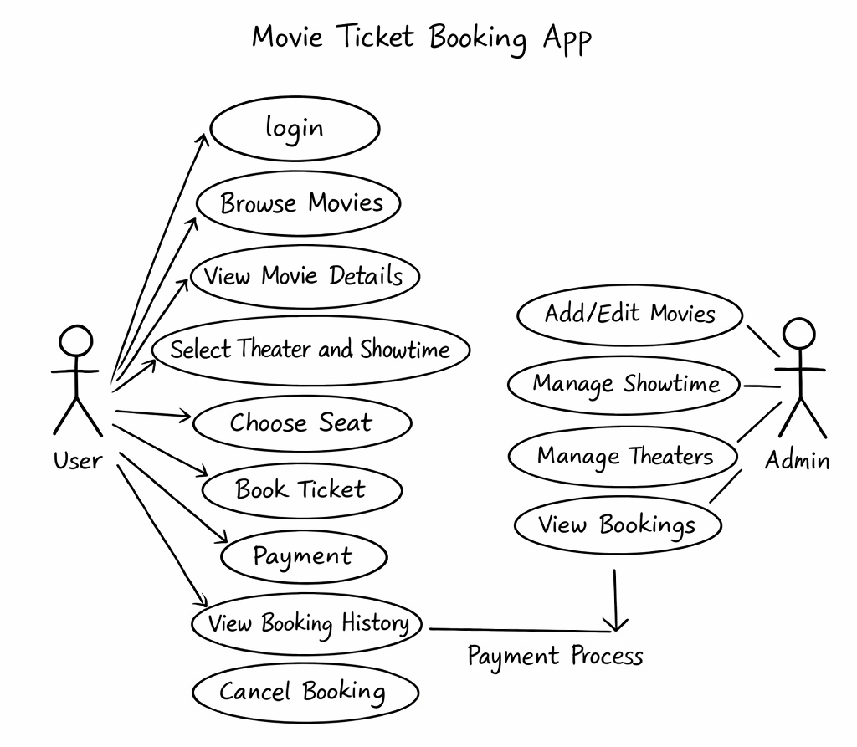
FIG:USE CASE DIAGRAM

Appendix C: EVOLUTION(VERSION2.0)

  - Payment provider details
  - UI design improvements
  - Payment provider details
  - UI design improvements
  - BAR CODE TICKETS
  - BAR CODE CHECKER FOR HALL OWNERS

